NAME : E.G.PRADEEP

ROLL NO : RA2211004050026

SUB : COMMUNICATION LABORATORY

ASSIGNMENT-1

1.SINE FUNCTION

CODE:

% Define the range of x values (from 0 to 2π)

x = linspace(0, 2\*pi, 100); % 100 points between 0 and 2π

% Compute the sine of each x value

y = sin(x);

% Plot the sine function

figure; % Create a new figure window

plot(x, y, 'b', 'LineWidth', 2); % Blue sine curve with thick line

hold on;

% Add x and y axis lines

plot([0 2\*pi], [0 0], 'k--'); % Dashed black x-axis

plot([pi/2, pi/2], [-1, 1], 'r--'); % Vertical line at π/2

% Labels and title

xlabel('x (radians)');

ylabel('sin(x)');

title('Sine Function Plot');

grid on; % Add grid

% Customize axis limits

xlim([0 2\*pi]);

ylim([-1.2 1.2]);

% Show important points

xticks([0 pi/2 pi 3\*pi/2 2\*pi]);

xticklabels({'0','\pi/2','\pi','3\pi/2','2\pi'});

% Display the plot

hold off;

OUTPUT:

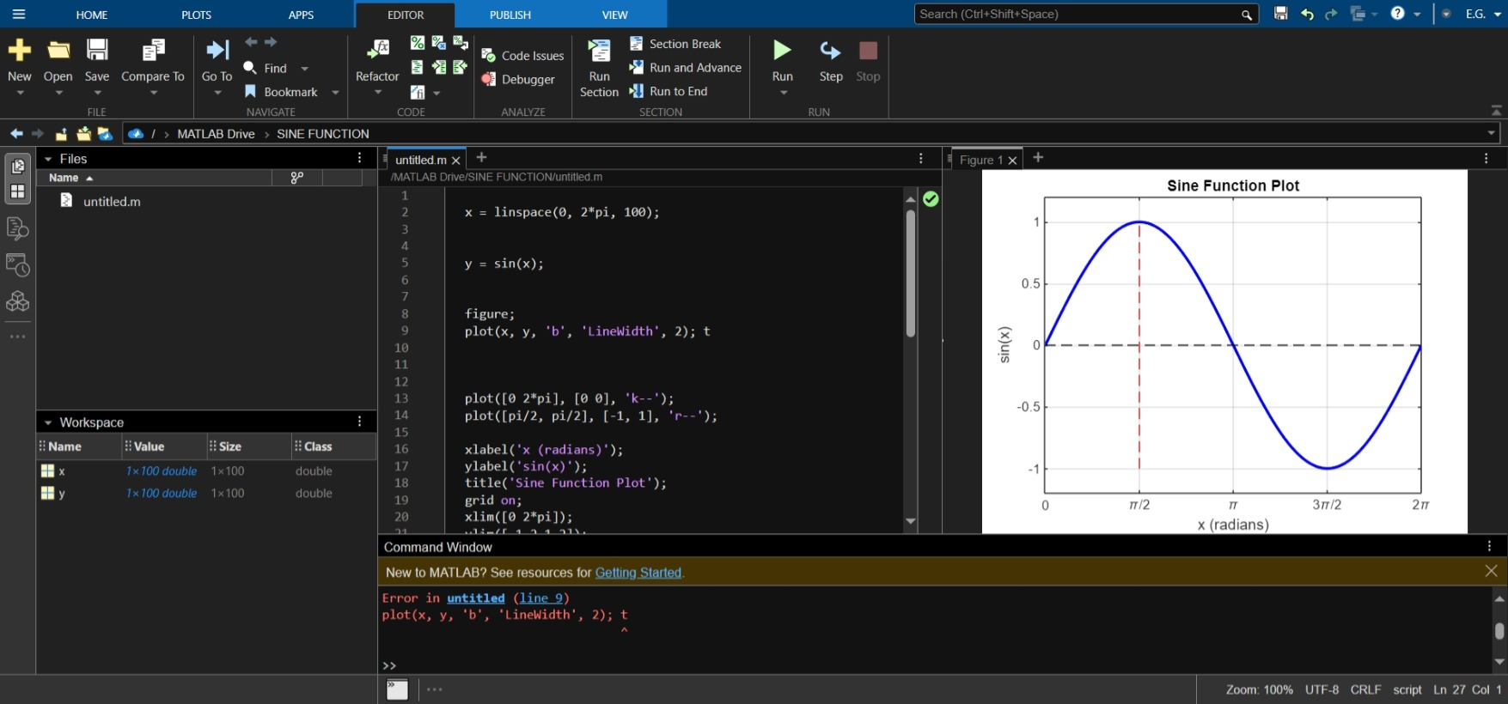

2.STEP FUNCTION

CODE :

% Define the range of x values

x = -5:0.1:5; % Values from -5 to 5 with a step of 0.1

% Define the step function using Heaviside function

y = heaviside(x);

% Plot the step function

figure;

plot(x, y, 'b', 'LineWidth', 2); % Blue line with thickness 2

hold on;

% Add x and y axis lines

plot([min(x) max(x)], [0 0], 'k--'); % Dashed x-axis

plot([0 0], [-0.2 1.2], 'k--'); % Dashed y-axis

% Labels and title

xlabel('x');

ylabel('Step Function u(x)');

title('Step Function (Heaviside)');

grid on; % Add grid

% Customize axis limits

ylim([-0.2, 1.2]);

% Display the plot

hold off;

OUTPUT:

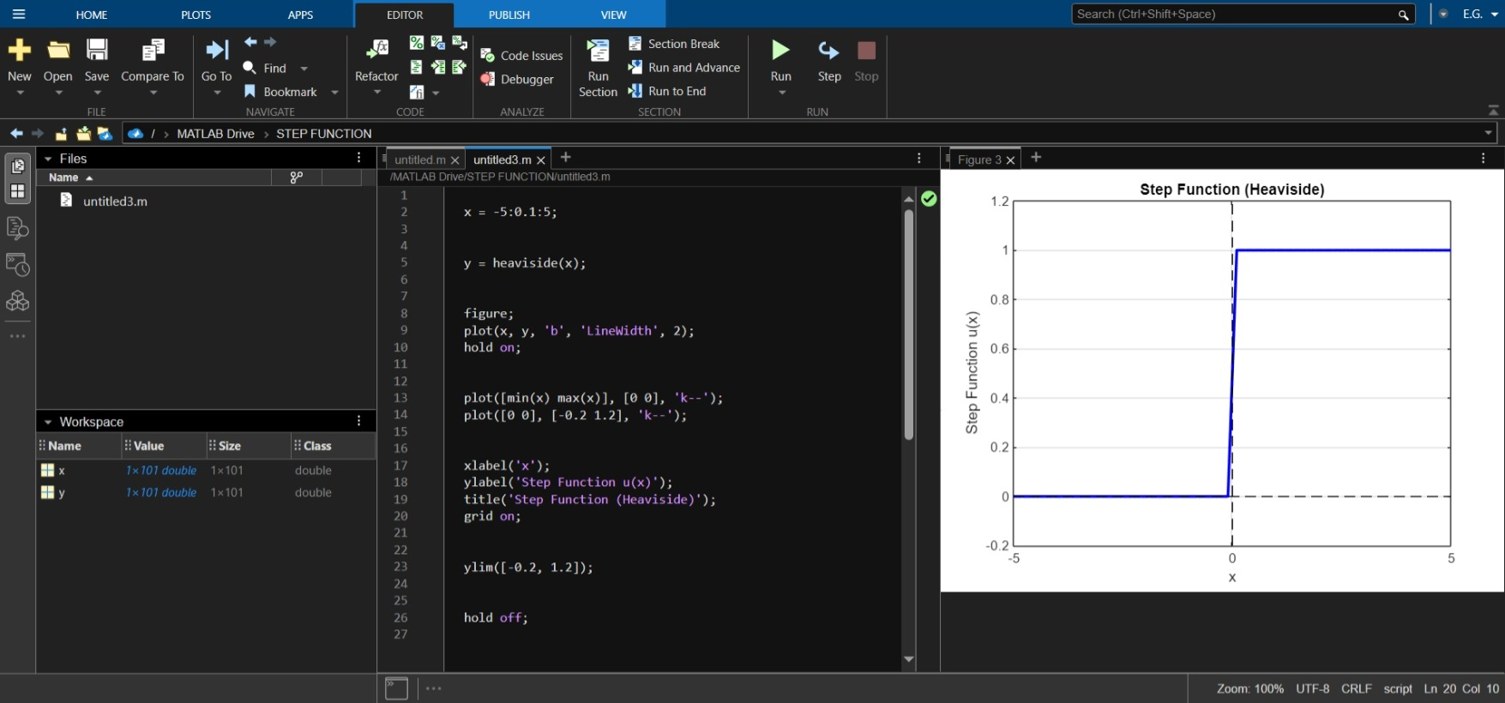

3.RAMP FUNCTION

CODE:

x = -5:0.1:5;

y = max(0, x);

figure;

plot(x, y, 'b', 'LineWidth', 2);

hold on;

plot([min(x) max(x)], [0 0], 'k--');

plot([0 0], [min(y) max(y)], 'k--');

xlabel('x');

ylabel('Ramp Function r(x)');

title('Ramp Function r(x) = max(0, x)');

grid on;

ylim([-1, max(y) + 1]);

hold off;

OUTPUT:

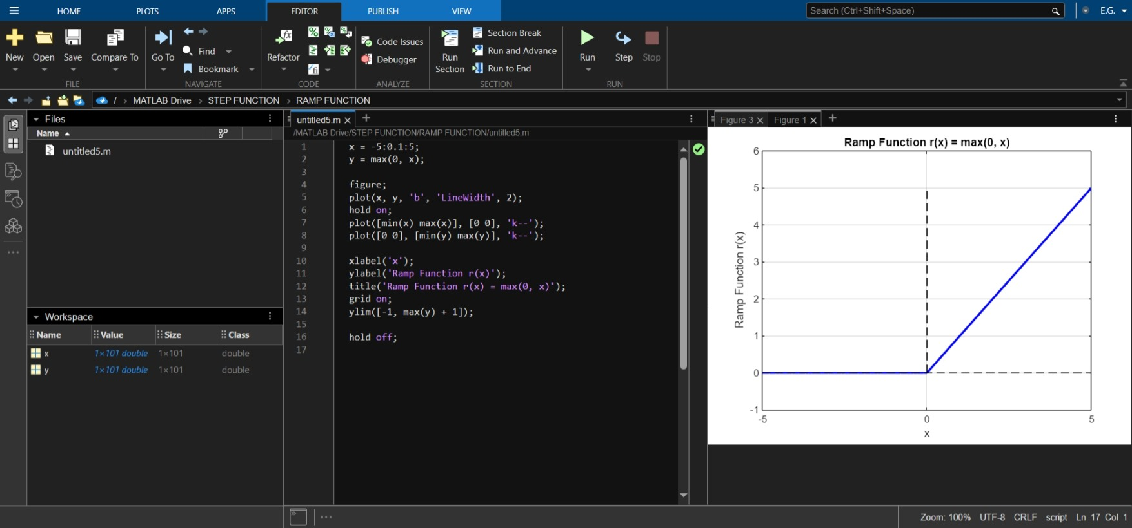

4.EXPONENTIAL(GROWING ANDDECAYING)

Code:

n = 0:10;

a = 1.2;

y = a.^n;

stem(n, y, 'b', 'LineWidth', 2);

xlabel('n');

ylabel('y[n]');

title('Growing Exponential Sequence');

grid on;

OUTPUT:

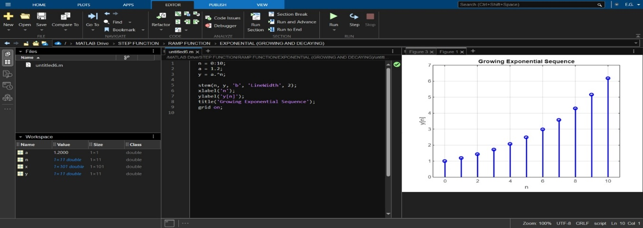

5.IMPULSE FUNCTION

CODE:

n = -5:5;

y = (n == 0);

stem(n, y, 'b', 'LineWidth', 2);

xlabel('n');

ylabel('\delta[n]');

title('Unit Impulse Function');

grid on;

OUTPUT:

